**PROGRAM 4: WEBSITE + STORAGE REPORT   
Chandler Ford | CSS 490: Cloud Computing | November 2018**

**Location of the URL for your site**<https://program4ford.azurewebsites.net/>

**Location of where the blog/object is stored (make this public). We’ll check to make sure it is loaded there**<https://program4storageaccount.blob.core.windows.net/program4container/superFile>

**Clear design diagrams of final project**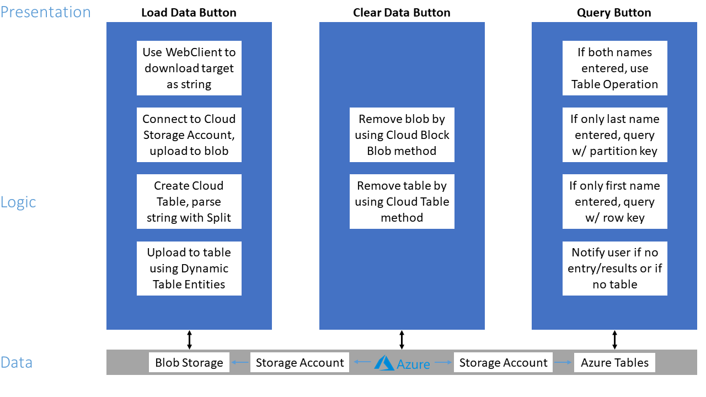

**Discussion of how the site will scale with load**My website is an App Service utilizing the Free tier of Azure. Auto scaling is not supported for this tier, and “in order to support scaling, the Web App needs to be in a service plan that supports automated scaling”.

**Discussion on how monitoring is done on the site**Thereis section titled “Monitoring” with several different options in the Azure Web Portal for App Services. In Alerts (Classic) metric/activity alerts can be set to notify users about things like Http errors and security. Logs can be turned on in the Diagnostic logs section for blobs, web servers, and filesystems. It is also possible to enable detailed error messages. A stream of the application logs can be viewed if they are enabled in Log stream. Process information such as the thread count, working set, private memory, and total CPU time can be found in the Process explorer. Several other options that provide more information about the Web App exist outside of the “Monitoring” section, such as Overview and Activity log.

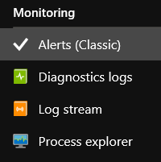

**Estimate of your SLA**My website is an App Service utilizing the Free tier of Azure. Microsoft states that “No SLA is provided for Apps under either the Free or Shared tiers”. Customers above those tiers are guaranteed 99.95% availability. The monthly uptime percentage is calculated using the formula Monthly Uptime % = (Maximum Available Minutes-Downtime)/(Maximum Available Minutes) x 100.

**Sources***For scaling*<https://azure.microsoft.com/en-us/pricing/details/app-service/windows/>  
<https://social.technet.microsoft.com/wiki/contents/articles/36366.azure-web-apps-scaling.aspx>

*For SLA*  
<https://azure.microsoft.com/en-us/support/legal/sla/summary/>  
<https://azure.microsoft.com/en-us/support/legal/sla/app-service/v1_4/>